use hr;

select * from employees;

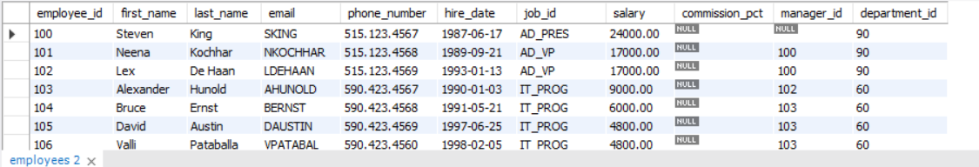

select * from countries;

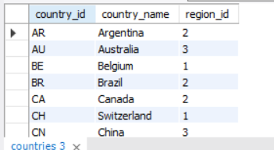

select country_id,region_id from countries;

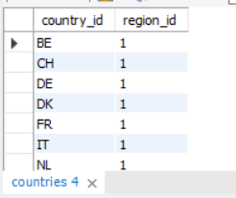

select department_id,location_id from departments;

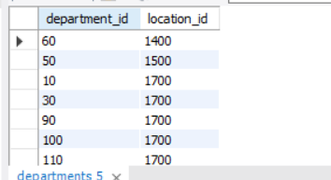

select employee_id,(salary*12)+100 annual from employees;

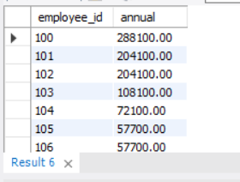

select concat( first_name , last_name ) as "Name" from employees;

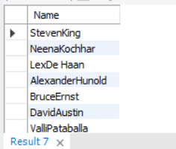

select concat( first_name ,job_id ) as "names with job" from employees;



select distinct department_id from employees;

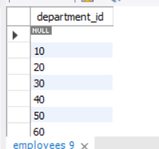

select employee_id,hire_date,job_id from employees where department_id = '80';

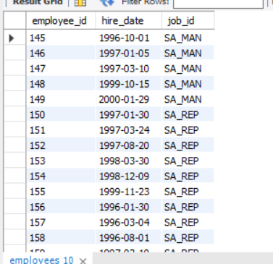

select employee_id,hire_date,job_id from employees where date_format( hire_date ,'%Y')= '1999';

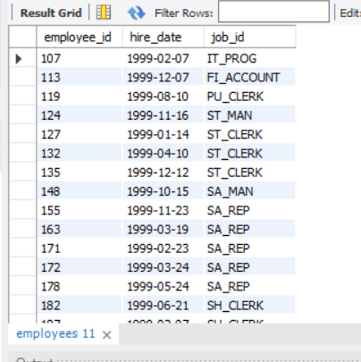

select employee_id,date_format( hire_date, '%W %D %M %Y' ) as Date , job_id from employees where date_format( hire_date ,'%Y')= '1999';

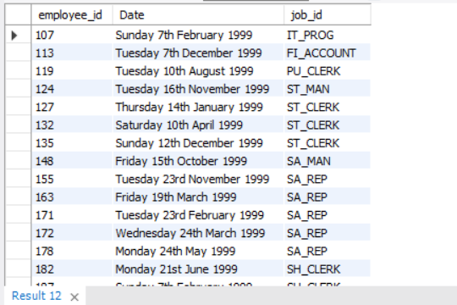

select employee_id, concat( first_name , last_name ) as "Name" , salary from employees where salary = 3000;

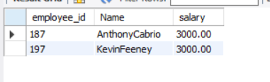

select employee_id, concat( first_name , last_name ) as "Name" , salary from employees where salary >= 15000;

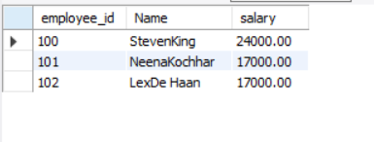

select employee_id, concat( first_name , last_name ) as "Name" , salary from employees where salary <= 3000;

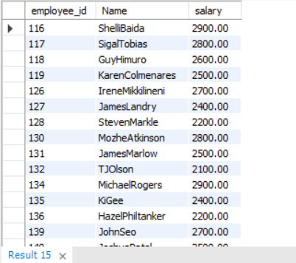

select employee_id, concat( first_name , last_name ) as "Name" , salary from employees where salary <> 6000;

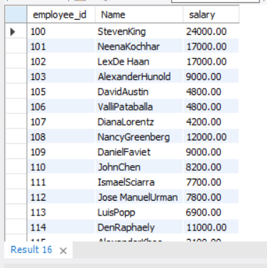

select employee_id, concat( first_name , last_name ) as "Name" , salary from employees where salary between 15000 and 30000;

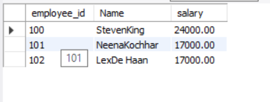

select employee_id, manager_id, salary from employees where manager_id in (100,101,110);

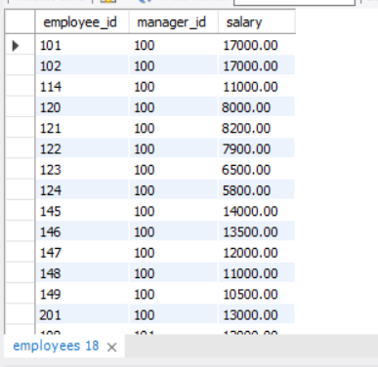

select concat( first_name , last_name ) as "Name" from employees where last_name like '%S';

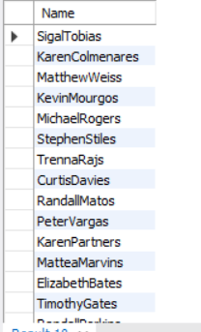

select concat( first_name , last_name ) as "Name" from employees where last_name like '%o%';



select concat( first_name , last_name ) as "Name" from employees where last_name like '%op%';



select concat( first_name , last_name ) as "Name" from employees where manager_id is null;



select concat( first_name , last_name ) as "Name" from employees

where ((salary >= 5000) and (job_id like '%MAN%'));

